**Learner Details**

* **Name:Nikhil k**
* **Enrollment Number: su625mr004**
* **Batch / Class: Mern Stack**
* **Assignment: Menu card**
* **Date of Submission: 07-07-2025**

**Problem Solving Activity 1.1**

**1. Program Statement**

Create a restaurant menu webpage where users can view different categories of food items, filter them by type (All, Starters, Main Course, Desserts), and add items to a shopping cart with a live cart count.

**2. Algorithm**

• Structure the HTML with a header containing the restaurant name, navigation links, and a cart count display.

• Create category filter buttons that trigger the filterItems() function to display relevant menu items.

• Display menu items within <section id="menu-items">, each containing an image, name, description, price, and an “Add to Cart” button.

• On clicking “Add to Cart,” run the addToCart() function to increase the cart count.

• Use CSS for layout and styling, and JavaScript to handle filtering and cart updates.

**3. Pseudocode**

START

DISPLAY header with restaurant name, navigation, and cart count

SHOW category buttons for filtering menu items

DISPLAY menu items with image, details, and Add to Cart button

FUNCTION filterItems(category):

IF category == 'all' THEN SHOW all items

ELSE SHOW only items matching category

FUNCTION addToCart():

INCREMENT cart count

UPDATE cart display

END

**4. Program Code**

<!DOCTYPE html>

<html lang="en">

<head>

  <meta charset="UTF-8">

  <title>Tasty Bites</title>

  <link rel="stylesheet" href="styles.css">

</head>

<body>

  <header>

    <div class="logo">TASTY BITES</div>

    <nav>

      <a href="#">Home</a>

      <a href="#">Menu</a>

      <a href="#">Contact</a>

      <span class="cart"><span id="cart-count">0</span></span>

    </nav>

  </header>

  <main>

    <h1>Menu</h1>

    <div class="categories">

      <button onclick="filterItems('all')">All</button>

      <button onclick="filterItems('starter')">Starters</button>

      <button onclick="filterItems('main')">Main Course</button>

      <button onclick="filterItems('dessert')">Desserts</button>

    </div>

    <section id="menu-items">

      <div class="item starter">

        <img src="/images/Bruschetta.jpg" alt="Bruschetta">

        <h3>Bruschetta</h3>

        <p>Grilled bread with garlic, tomatoes, and basil</p>

        <p>$5.99</p>

        <button onclick="addToCart()">Add to Cart</button>

      </div>

      <div class="item main">

        <img src="/images/pizza.jpeg" alt="Pizza">

        <h3>Margherita Pizza</h3>

        <p>Classic pizza with tomatoes, mozzarella, and basil</p>

        <p>$12.99</p>

        <button onclick="addToCart()">Add to Cart</button>

      </div>

      <div class="item main">

        <img src="/images/salmon.jpeg" alt="Grilled Salmon">

        <h3>Grilled Salmon</h3>

        <p>Salmon fillet with a side of vegetables</p>

        <p>$18.99</p>

        <button onclick="addToCart()">Add to Cart</button>

      </div>

      <div class="item dessert">

        <img src="/images/tiramisu.jpg" alt="Tiramisu">

        <h3>Tiramisu</h3>

        <p>Classic Italian dessert with mascarpone and coffee</p>

        <p>$6.99</p>

        <button onclick="addToCart()">Add to Cart</button>

      </div>

    </section>

  </main>

  <script src="script.js"></script>

</body>

</html>

**5. Test Cases**

| **Action** | **Expected Result** |
| --- | --- |
| **Page load** | **All menu items displayed, cart count = 0** |
| **Click "Starters"** | **Only starter items displayed** |
| **Click "Desserts"** | **Only dessert items displayed** |
| **Click "Add to Cart" on any item** | **Cart count increases by 1 each click** |
| **Click "All"** | **All menu items displayed again** |

**6. Screenshots of Output**

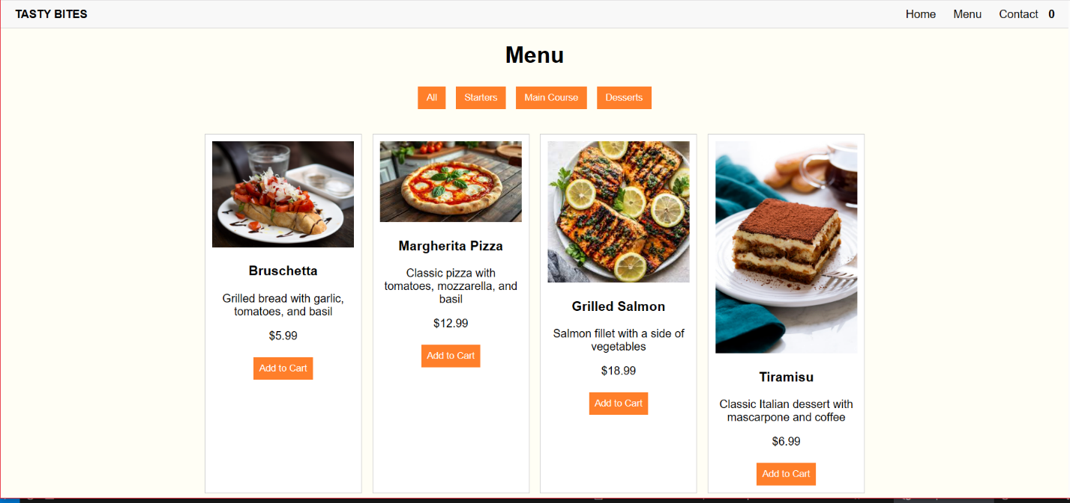

**7. Observation / Reflection**

• I learned how to structure a webpage for an online restaurant menu using HTML and interactive JavaScript functions.

• Implementing filterItems() helped me understand DOM manipulation for showing/hiding elements.

• Updating the cart count dynamically taught me how to modify webpage content in real-time.